**ACCOUNT :**

package com.cognizant.account.controller;  
  
public class Account {  
 private String number;  
 private String type;  
 private double balance;  
 public Account(String number,String type,double balance){  
 this.number=number;  
 this.type=type;  
 this.balance=balance;  
 }  
 public String getNumber(){  
 return number;  
 }  
 public String getType(){  
 return type ;  
 }  
 public double getBalance(){  
 return balance;  
 }  
}

**ACCOUNTCONTROLLER:**

package com.cognizant.account.controller;  
  
import org.springframework.web.bind.annotation.GetMapping;  
import org.springframework.web.bind.annotation.PathVariable;  
import org.springframework.web.bind.annotation.RequestMapping;  
import org.springframework.web.bind.annotation.RestController;  
  
@RestController  
@RequestMapping("/accounts")  
public class AccountController {  
 @GetMapping("/{number}")  
 public Account getAccountByNumber(@PathVariable String number){  
 return new Account(number,"Savings money",234341);  
 }  
}

**ACCOUNTAPPLICATION:**

package com.cognizant.account;  
  
import org.springframework.boot.SpringApplication;  
import org.springframework.boot.autoconfigure.SpringBootApplication;  
  
@SpringBootApplication  
public class AccountApplication {  
 public static void main(String[] args) {  
 SpringApplication.*run*(AccountApplication.class,args);  
 }  
}

**ACCOUNT OUTPUT:**

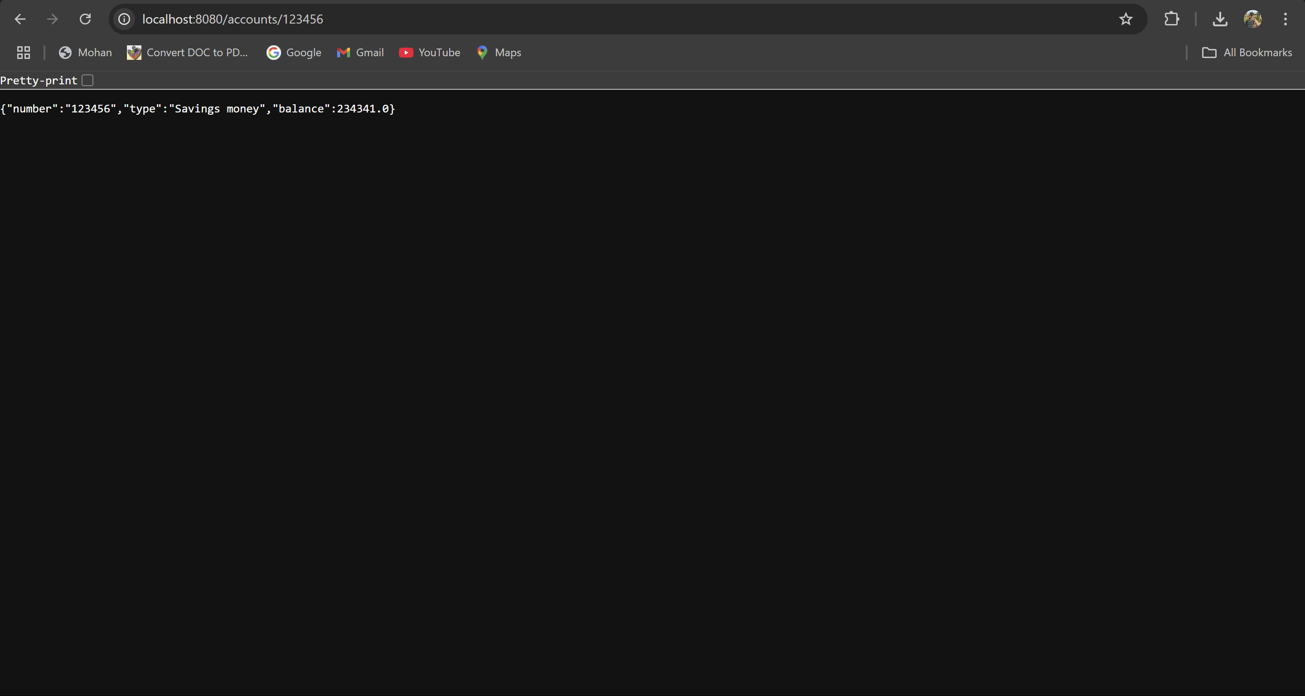

**LOANAPPLICATION:**

package com.cognizant.loan;  
  
import org.springframework.boot.SpringApplication;  
import org.springframework.boot.autoconfigure.SpringBootApplication;  
  
@SpringBootApplication  
public class LoanApplication {  
 public static void main(String[] args) {  
 SpringApplication.*run*(LoanApplication.class,args);  
 }  
}

**LOANCONTROLLER:**

package com.cognizant.loan.controller;  
  
import org.springframework.web.bind.annotation.GetMapping;  
import org.springframework.web.bind.annotation.PathVariable;  
import org.springframework.web.bind.annotation.RequestMapping;  
import org.springframework.web.bind.annotation.RestController;  
  
@RestController  
public class LoanController {  
 @GetMapping("/number/{number}")  
 public Loan getLoanByNumber(@PathVariable String number){  
 return new Loan(number,"Bike",250000,45876,10);  
 }  
}

**LOAN:**

package com.cognizant.loan.controller;  
  
public class Loan {  
 private String number;  
 private String type;  
 private double loan;  
 private double emi;  
 private int tenure;  
  
 public Loan(String number, String type, double loan, double emi, int tenure) {  
 this.number = number;  
 this.type = type;  
 this.loan = loan;  
 this.emi = emi;  
 this.tenure = tenure;  
 }  
  
 public String getNumber()  
 {  
 return number;  
 }  
 public String getType()  
 {  
 return type;  
 }  
 public double getLoan()  
 {  
 return loan;  
 }  
 public double getEmi()  
 {  
 return emi;  
 }  
 public int getTenure()  
 {  
 return tenure;  
 }  
}

**LOANOUTPUT:**

